MASCHERPA Audric ROB 3 2022 / 2023

**POLY-SNAKE**

**Weekly report n°9 from 16/12/22 :**

Following the end of the previous session, the shape of the snake's head could be modeled on paper. Nevertheless, it was now necessary to model it in 3D, keeping in mind that the size of this module had to be consistent with those made previously which constitute the body of the snake.

Thus, we can see in Figure 9.1 and 9.2 the progress of the modeling with the Arduino board in pink, the Nvidia board in light blue, the motor in orange and finally the motor control board in dark blue.

Figure 9.2

Figure 9.1

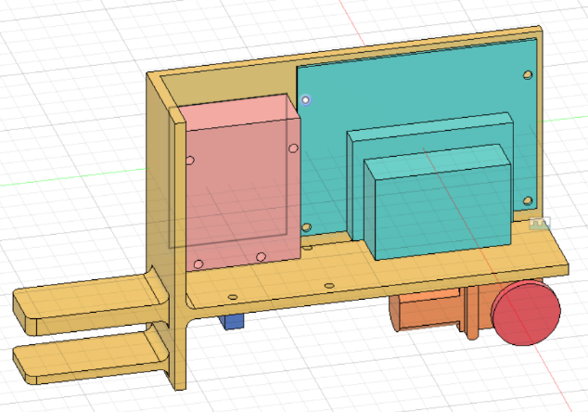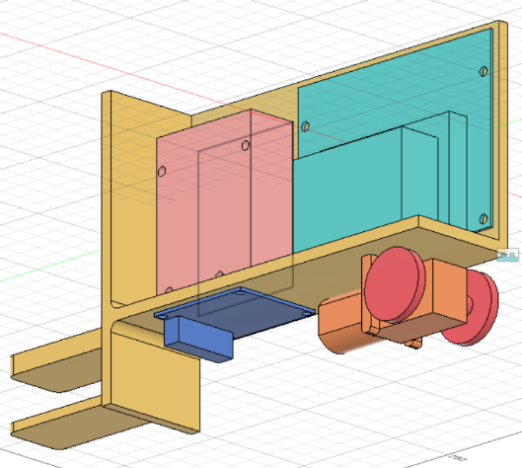

Unfortunately, due to the presence of many components, the snake's head will be too large compared to the rest of the body. Thus it will then be necessary to change the size of the modules of the snake's body in order to have a body of size proportional to the head and to get as close as possible to a real snake.

The modeling could not be completed due to a two-hour slowdown session.